Performance Testing
Execution&Report Submission
Date | 07 September 2026
Name | V.Maheswari
Project Name | Incident Lifecycle Automation in ServiceNow
Maximum Marks | 4 Marks
1. Purpose of Document
The purpose of this document is to briefly explain the performance-test coverage, workload scenarios, expected performance measures, and open performance issues for the Incident Lifecycle Automation in ServiceNow project. The scope is aligned to the incident lifecycle described in the project requirements: incident creation and classification, reassignment, knowledge usage, Level 2 investigation and resolution, emergency change creation, child incidents, and knowledge article generation.
2. Performance Test Analysis
This report identifies the performance areas to be evaluated. No executed performance measurements or load-test results were included in the supplied project materials; therefore, the Pass/Fail status below is recorded as Not Executed rather than inventing results.
Performance Area | Workload | Measures | Status
Incident Creation&Classification | Create incidents and populate classification fields | Response time, throughput, error rate | Not Executed
Incident List&Search | Open/filter incident lists and search records | Page response time, concurrent-user stability | Not Executed
Assignment&Reassignment | Assign incidents to appropriate support groups | Transaction response time, errors | Not Executed
Knowledge Management | Search/attach knowledge and generate knowledge content | Search response time, transaction time | Not Executed
L2 Investigation&Resolution | Update work notes, state and resolution details | Update response time, throughput | Not Executed
Emergency Change / Child Incident | Create related change or child incident from an incident | Transaction time, error rate | Not Executed
Performance acceptance should be based on agreed response-time, throughput, concurrency and error-rate thresholds for the target ServiceNow environment.

3. Test Case Analysis
This report shows the planned performance test cases by functional area. The supplied material provides project screenshots but does not provide a performance execution log, timings, concurrency results, or defect register; accordingly, the current execution status is Not Tested.
Section | Total Cases | Not Tested | Fail | Pass
Incident Creation | 3 | 3 | 0 | 0
Incident Classification&Update | 2 | 2 | 0 | 0
Incident Assignment / Reassignment | 2 | 2 | 0 | 0
Knowledge Search / Attach | 2 | 2 | 0 | 0
L2 Investigation&Resolution | 2 | 2 | 0 | 0
Emergency Change / Child Incident | 2 | 2 | 0 | 0
Knowledge Article Generation | 2 | 2 | 0 | 0
Total | 15 | 15 | 0 | 0
4. ServiceNow Project Evidence
The following project screenshots are included as visual evidence of the ServiceNow incident-management functions covered by the performance scope. They are reproduced from the supplied ServiceNow project images PDF.
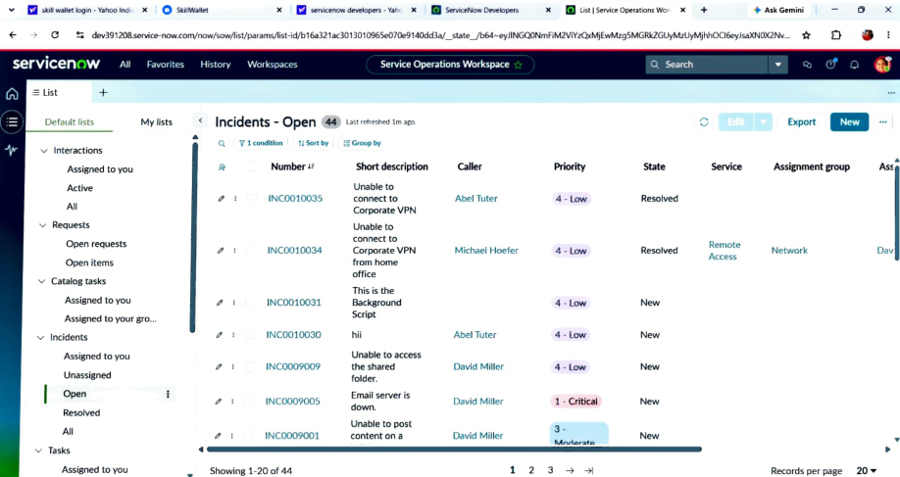  Incident list and filtering | 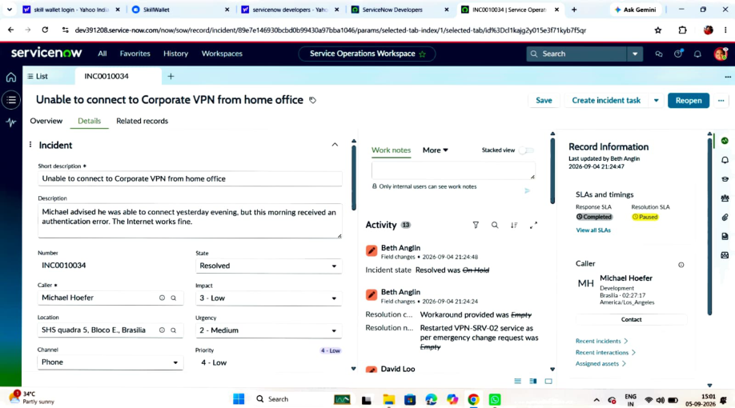  Incident record, activity and SLA view
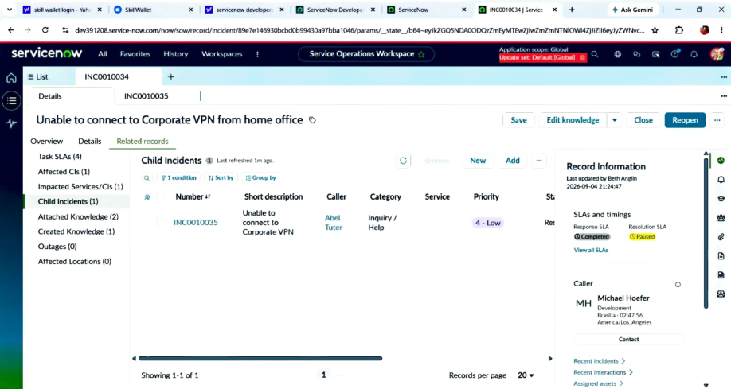
Child incident / related-record view

